CYB 210 3-3 Activity: Subnetting Practice
Andree Salvo
Southern New Hampshire University
Cyb 210
Instructor: Bruce Gonzalez
2/28/2025
2025
First Problem:
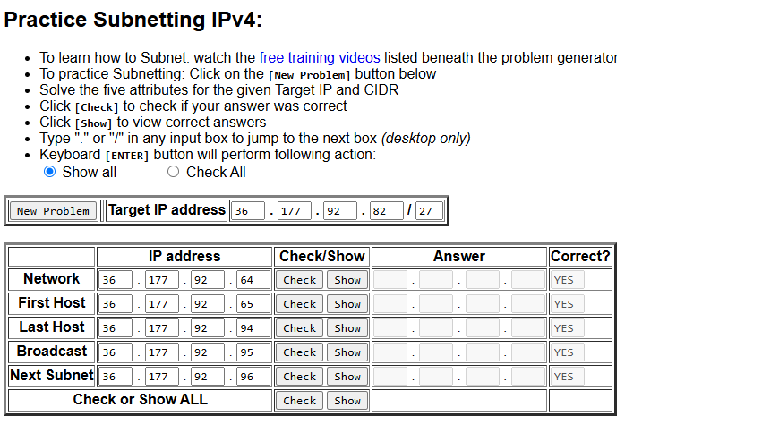
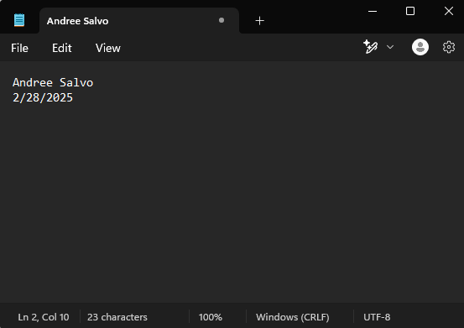

Second Problem:
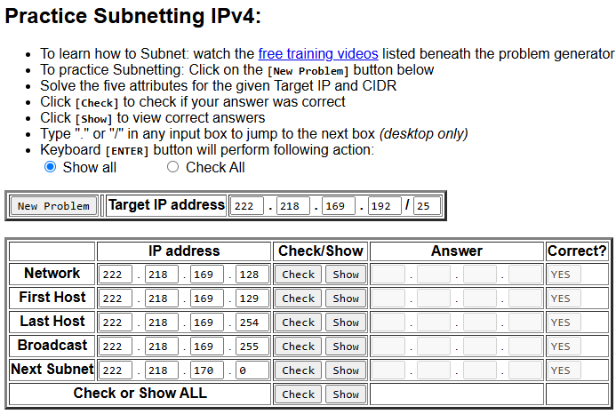
Third Problem:
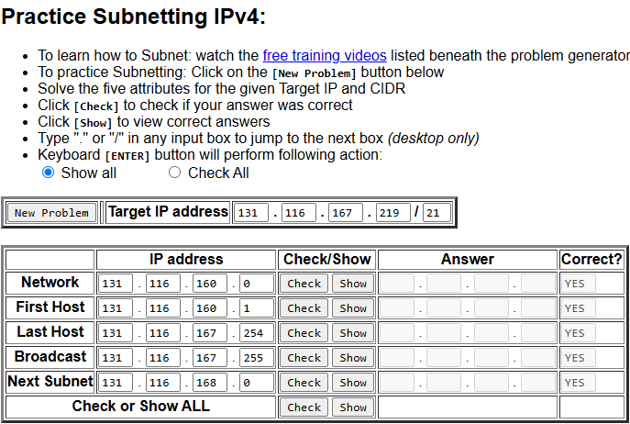
Fourth Problem:
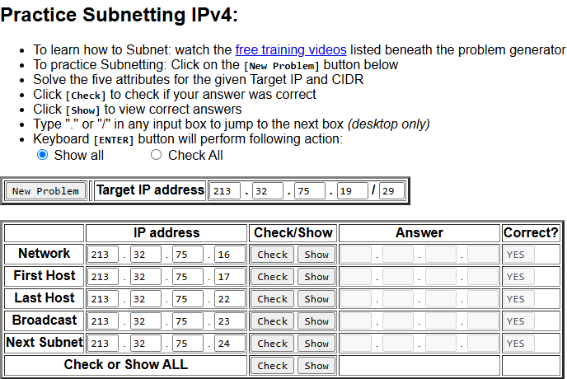
Fifth Problem:
